Practical 6
Problem Definition
Display event lists, student profiles, notices, or FAQs from external JSON files using Fetch API. Implement dynamic rendering, search, filter, sorting, and pagination.
Events.html:-
<!DOCTYPE html>
<html lang="en">
<head>
<meta charset="UTF-8">
<meta name="viewport" content="width=device-width, initial-scale=1.0">
<title>StudentHub - Events</title>
<link rel="stylesheet" href="css/style.css">
</head>
<body>

<header>
<h1>StudentHub Events</h1>
</header>

<main>
<a href="index.html"><button>Home</button></a>

<br><br>

<input type="text" id="searchInput" placeholder="Search events">

<select id="categoryFilter">
<option value="all">All Categories</option>
<option value="Technical">Technical</option>
<option value="Sports">Sports</option>
<option value="Cultural">Cultural</option>
<option value="Workshop">Workshop</option>
<option value="Academic">Academic</option>
</select>

<select id="sortSelect">
<option value="default">Default</option>
<option value="name">Name</option>
<option value="date">Date</option>
</select>

<p id="loading">Loading events...</p>
<p id="error"></p>

<div id="eventList"></div>
<div id="pagination"></div>
</main>

<script src="js/events.js"></script>
</body>
</html>
Events.js:-
let events = [];
let currentPage = 1;
const recordsPerPage = 5;

fetch("data/events.json")
.then(response => {
if (!response.ok) {
throw new Error("Failed to load events.");
}
return response.json();
})
.then(data => {
events = data;
document.getElementById("loading").style.display = "none";
displayEvents();
})
.catch(error => {
document.getElementById("loading").style.display = "none";
document.getElementById("error").textContent = error.message;
});

function displayEvents() {
let search = document.getElementById("searchInput").value.toLowerCase();
let category = document.getElementById("categoryFilter").value;
let sortValue = document.getElementById("sortSelect").value;

let filtered = events.filter(event => {
let matchesSearch = event.name.toLowerCase().includes(search);
let matchesCategory = category === "all" || event.category === category;
return matchesSearch && matchesCategory;
});

if (sortValue === "name") {
filtered.sort((a, b) => a.name.localeCompare(b.name));
} else if (sortValue === "date") {
filtered.sort((a, b) => new Date(a.date) - new Date(b.date));
}

let start = (currentPage - 1) * recordsPerPage;
let pageData = filtered.slice(start, start + recordsPerPage);

let list = document.getElementById("eventList");
list.innerHTML = "";

pageData.forEach(event => {
list.innerHTML += `
<div class="card">
<h3>${event.name}</h3>
<p><b>Category:</b> ${event.category}</p>
<p><b>Date:</b> ${event.date}</p>
<p><b>Venue:</b> ${event.venue}</p>
</div>
`;
});

createPagination(filtered.length);
}

function createPagination(totalRecords) {
let totalPages = Math.ceil(totalRecords / recordsPerPage);
let pagination = document.getElementById("pagination");
pagination.innerHTML = "";

for (let i = 1; i <= totalPages; i++) {
let button = document.createElement("button");
button.textContent = i;

if (i === currentPage) {
button.disabled = true;
}

button.onclick = () => {
currentPage = i;
displayEvents();
};

pagination.appendChild(button);
}
}

document.getElementById("searchInput").addEventListener("input", () => {
currentPage = 1;
displayEvents();
});

document.getElementById("categoryFilter").addEventListener("change", () => {
currentPage = 1;
displayEvents();
});

document.getElementById("sortSelect").addEventListener("change", () => {
currentPage = 1;
displayEvents();
});
Events.json:-
[
{"id":1,"name":"Tech Fest 2026","category":"Technical","date":"2026-10-05","venue":"Main Auditorium"},
{"id":2,"name":"Sports Day","category":"Sports","date":"2026-10-08","venue":"College Ground"},
{"id":3,"name":"Coding Competition","category":"Technical","date":"2026-10-12","venue":"Computer Lab"},
{"id":4,"name":"Cultural Festival","category":"Cultural","date":"2026-10-15","venue":"Open Stage"},
{"id":5,"name":"Web Development Workshop","category":"Workshop","date":"2026-10-18","venue":"Seminar Hall"},
{"id":6,"name":"Robotics Exhibition","category":"Technical","date":"2026-10-20","venue":"Innovation Lab"},
{"id":7,"name":"Photography Contest","category":"Cultural","date":"2026-10-22","venue":"Student Center"},
{"id":8,"name":"Cricket Tournament","category":"Sports","date":"2026-10-25","venue":"College Ground"},
{"id":9,"name":"AI Workshop","category":"Workshop","date":"2026-10-28","venue":"Seminar Hall"},
{"id":10,"name":"Hackathon","category":"Technical","date":"2026-11-02","venue":"Computer Lab"},
{"id":11,"name":"Dance Competition","category":"Cultural","date":"2026-11-05","venue":"Open Stage"},
{"id":12,"name":"Football Tournament","category":"Sports","date":"2026-11-08","venue":"College Ground"},
{"id":13,"name":"Java Programming Workshop","category":"Workshop","date":"2026-11-10","venue":"Computer Lab"},
{"id":14,"name":"Quiz Competition","category":"Academic","date":"2026-11-12","venue":"Room 101"},
{"id":15,"name":"Annual Function","category":"Cultural","date":"2026-11-15","venue":"Main Auditorium"}
]

Screenshot:-
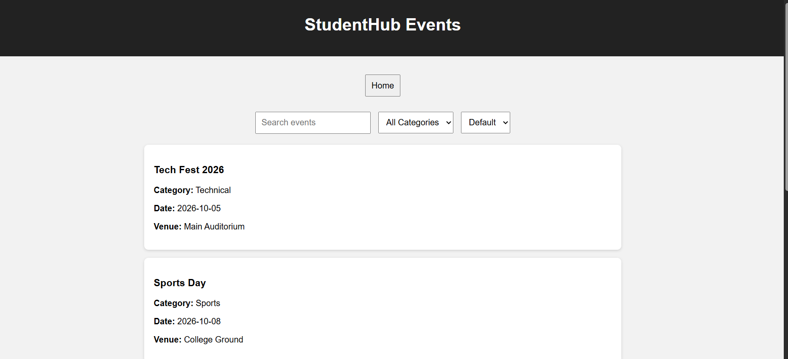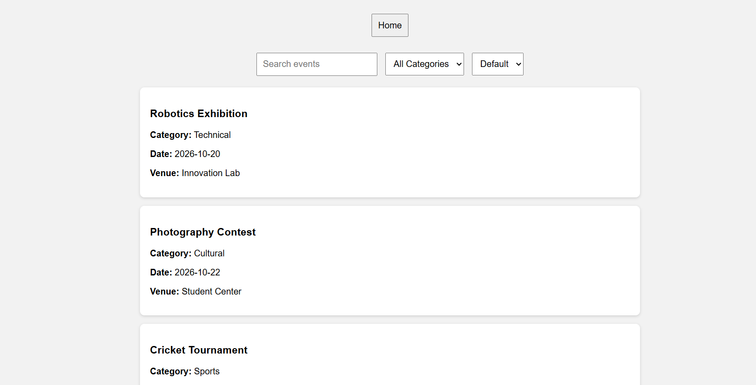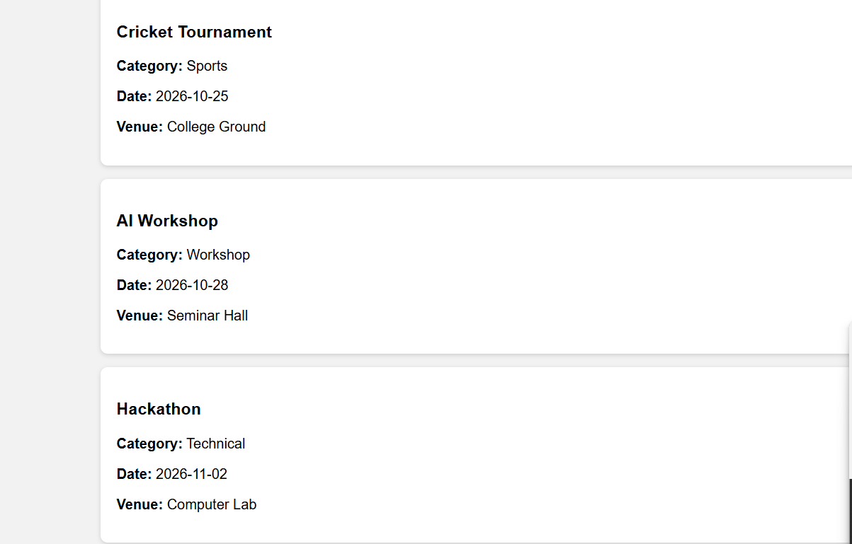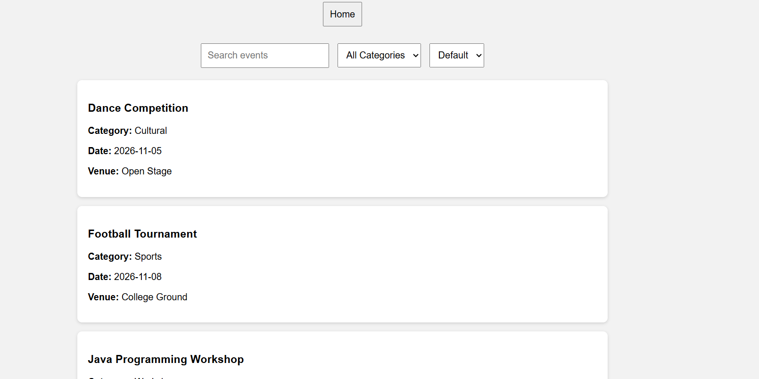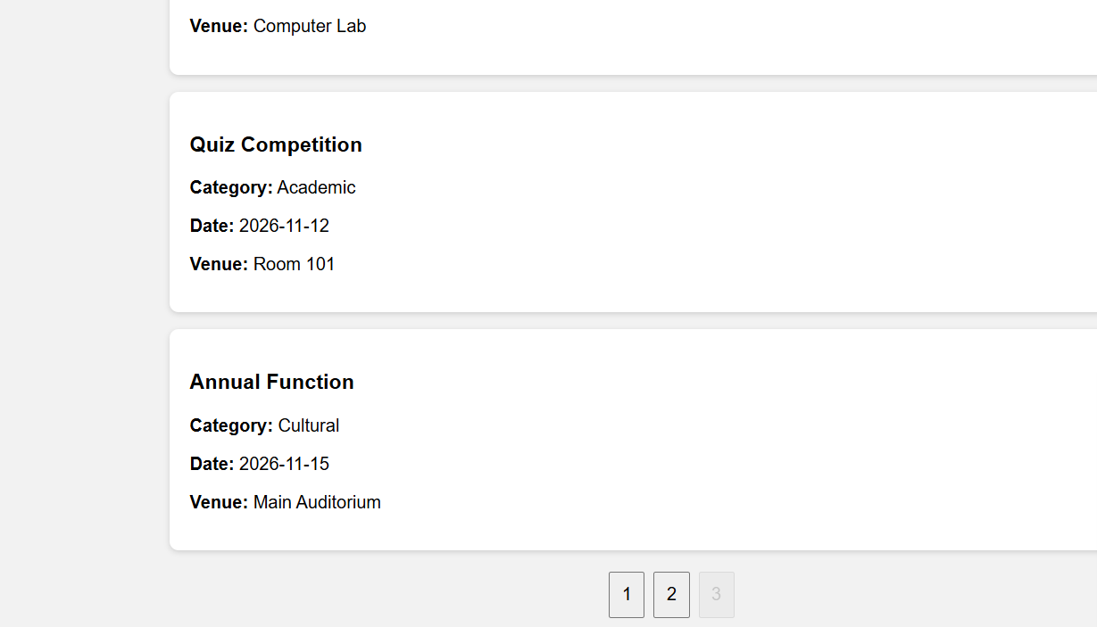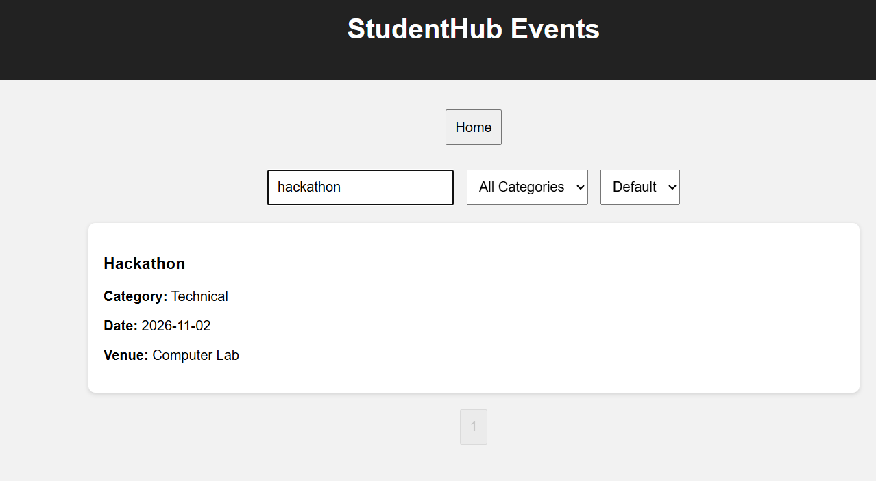
Students.html:-
<!DOCTYPE html>
<html lang="en">
<head>
<meta charset="UTF-8">
<meta name="viewport" content="width=device-width, initial-scale=1.0">
<title>StudentHub - Students</title>
<link rel="stylesheet" href="css/style.css">
</head>
<body>

<header>
<h1>Student Profiles</h1>
</header>

<main>
<a href="index.html"><button>Home</button></a>

<br><br>

<input type="text" id="studentSearch" placeholder="Search student">

<select id="courseFilter">
<option value="all">All Courses</option>
<option value="CSE">CSE</option>
<option value="IT">IT</option>
<option value="ECE">ECE</option>
<option value="ME">ME</option>
</select>

<button id="sortStudents">Sort by Name</button>

<p id="studentLoading">Loading students...</p>
<p id="studentError"></p>

<div id="studentList"></div>
<div id="studentPagination"></div>
</main>

<script src="js/students.js"></script>
</body>
</html>
Students.js:-
let students = [];
let studentPage = 1;
const studentRecordsPerPage = 5;

fetch("data/students.json")
.then(response => {
if (!response.ok) {
throw new Error("Failed to load students.");
}
return response.json();
})
.then(data => {
students = data;
document.getElementById("studentLoading").style.display = "none";
displayStudents();
})
.catch(error => {
document.getElementById("studentLoading").style.display = "none";
document.getElementById("studentError").textContent = error.message;
});

function displayStudents() {
let search = document.getElementById("studentSearch").value.toLowerCase();
let course = document.getElementById("courseFilter").value;

let filtered = students.filter(student => {
let matchesSearch = student.name.toLowerCase().includes(search);
let matchesCourse = course === "all" || student.course === course;
return matchesSearch && matchesCourse;
});

filtered.sort((a, b) => a.name.localeCompare(b.name));

let start = (studentPage - 1) * studentRecordsPerPage;
let pageData = filtered.slice(start, start + studentRecordsPerPage);

let list = document.getElementById("studentList");
list.innerHTML = "";

pageData.forEach(student => {
list.innerHTML += `
<div class="card">
<h3>${student.name}</h3>
<p><b>Course:</b> ${student.course}</p>
<p><b>Semester:</b> ${student.semester}</p>
<p><b>Email:</b> ${student.email}</p>
</div>
`;
});

createStudentPagination(filtered.length);
}

function createStudentPagination(totalRecords) {
let totalPages = Math.ceil(totalRecords / studentRecordsPerPage);
let pagination = document.getElementById("studentPagination");
pagination.innerHTML = "";

for (let i = 1; i <= totalPages; i++) {
let button = document.createElement("button");
button.textContent = i;

if (i === studentPage) {
button.disabled = true;
}

button.onclick = () => {
studentPage = i;
displayStudents();
};

pagination.appendChild(button);
}
}

document.getElementById("studentSearch").addEventListener("input", () => {
studentPage = 1;
displayStudents();
});

document.getElementById("courseFilter").addEventListener("change", () => {
studentPage = 1;
displayStudents();
});

document.getElementById("sortStudents").addEventListener("click", () => {
students.reverse();
studentPage = 1;
displayStudents();
});
Students.json:-
[
{"id":1,"name":"Akshay Kumar","course":"CSE","semester":3,"email":"akshay@example.com"},
{"id":2,"name":"Rahul Patel","course":"IT","semester":3,"email":"rahul@example.com"},
{"id":3,"name":"Priya Shah","course":"ECE","semester":2,"email":"priya@example.com"},
{"id":4,"name":"Neha Patel","course":"CSE","semester":4,"email":"neha@example.com"},
{"id":5,"name":"Amit Shah","course":"ME","semester":2,"email":"amit@example.com"},
{"id":6,"name":"Riya Mehta","course":"IT","semester":4,"email":"riya@example.com"},
{"id":7,"name":"Karan Joshi","course":"CSE","semester":3,"email":"karan@example.com"},
{"id":8,"name":"Pooja Desai","course":"ECE","semester":4,"email":"pooja@example.com"},
{"id":9,"name":"Vivek Patel","course":"ME","semester":3,"email":"vivek@example.com"},
{"id":10,"name":"Anjali Shah","course":"CSE","semester":2,"email":"anjali@example.com"},
{"id":11,"name":"Harsh Mehta","course":"IT","semester":3,"email":"harsh@example.com"},
{"id":12,"name":"Mansi Joshi","course":"ECE","semester":2,"email":"mansi@example.com"},
{"id":13,"name":"Dhruv Patel","course":"CSE","semester":4,"email":"dhruv@example.com"},
{"id":14,"name":"Nisha Desai","course":"IT","semester":2,"email":"nisha@example.com"},
{"id":15,"name":"Yash Shah","course":"ME","semester":4,"email":"yash@example.com"}
]

Screenshot:-
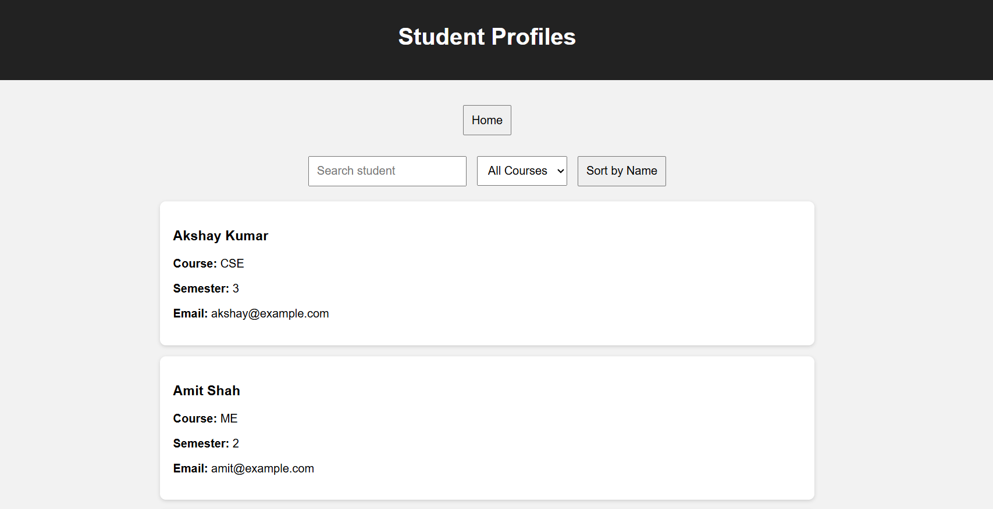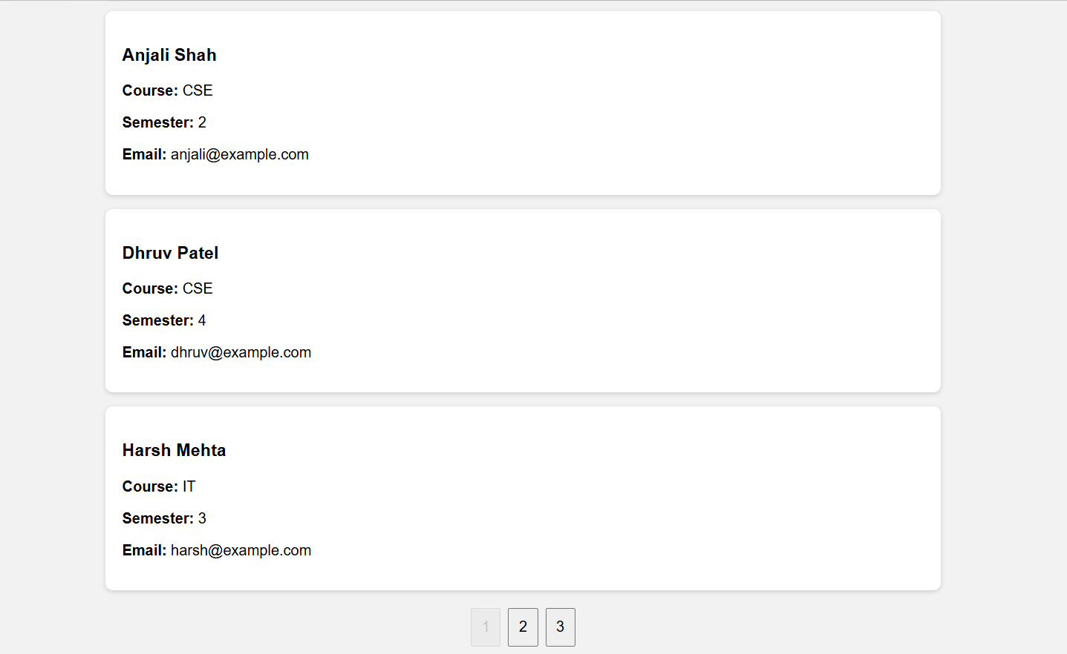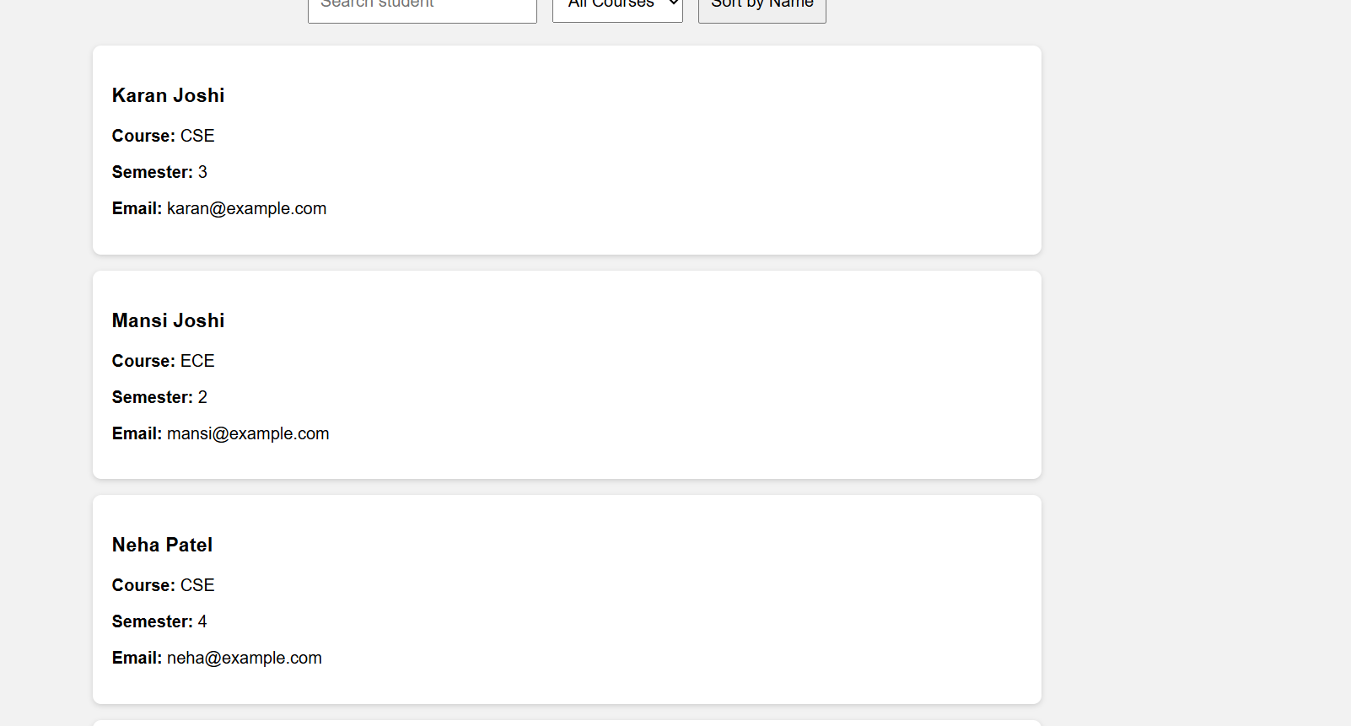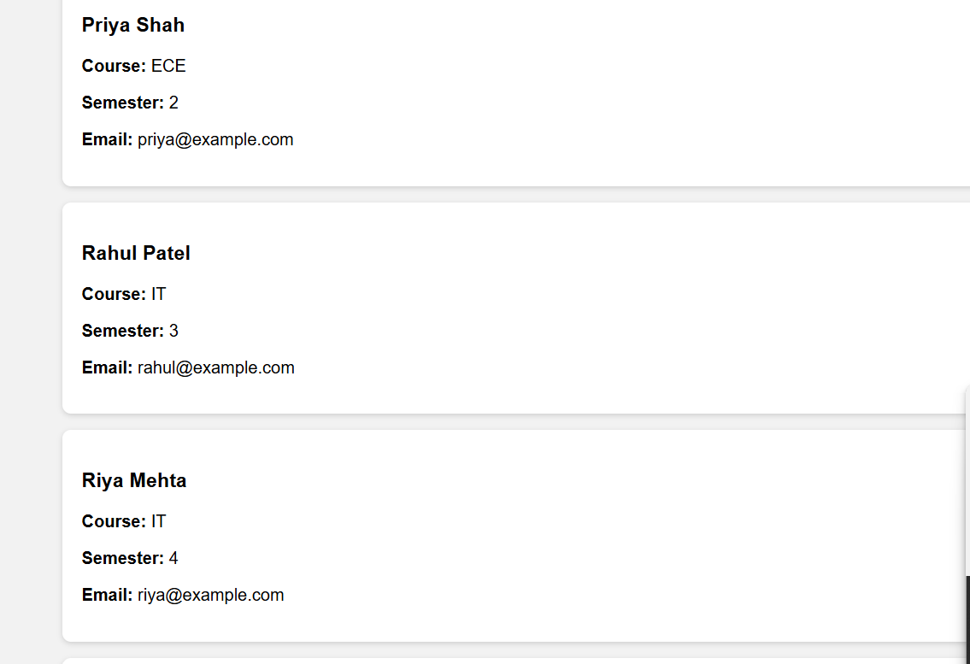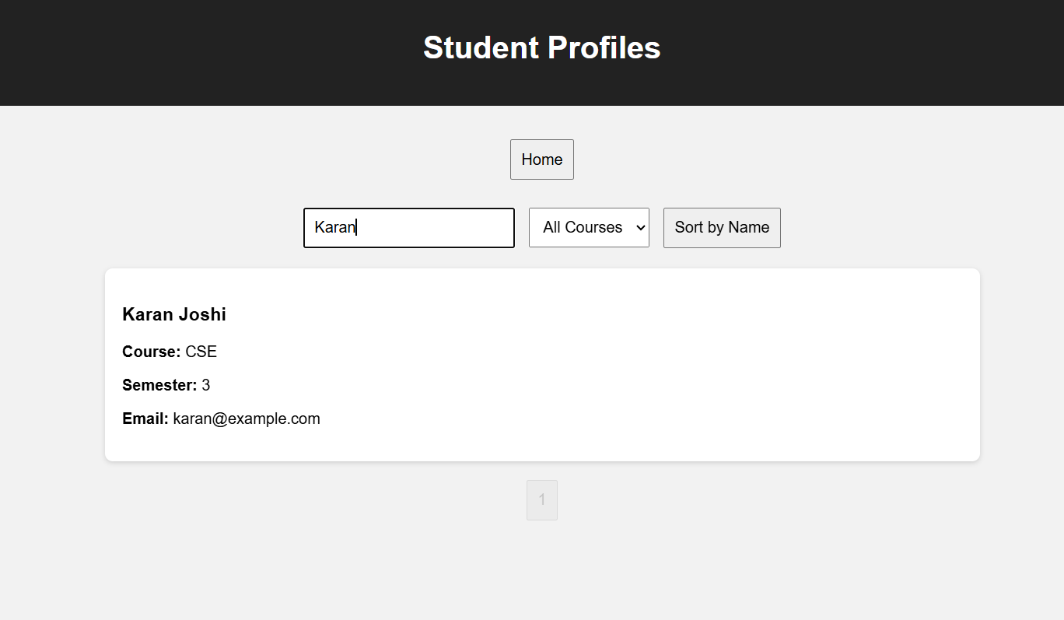
FAQs.html:-
<!DOCTYPE html>
<html lang="en">
<head>
<meta charset="UTF-8">
<meta name="viewport" content="width=device-width, initial-scale=1.0">
<title>StudentHub - FAQs</title>
<link rel="stylesheet" href="css/style.css">
</head>
<body>

<header>
<h1>StudentHub FAQs</h1>
</header>

<main>
<a href="index.html"><button>Home</button></a>

<br><br>

<input type="text" id="faqSearch" placeholder="Search FAQ">

<p id="faqLoading">Loading FAQs...</p>
<p id="faqError"></p>

<div id="faqList"></div>
<div id="faqPagination"></div>
</main>

<script src="js/faqs.js"></script>
</body>
</html>
FAQs.js:-
let faqs = [];
let faqPage = 1;
const faqRecordsPerPage = 5;

fetch("data/faqs.json")
.then(response => {
if (!response.ok) {
throw new Error("Failed to load FAQs.");
}
return response.json();
})
.then(data => {
faqs = data;
document.getElementById("faqLoading").style.display = "none";
displayFaqs();
})
.catch(error => {
document.getElementById("faqLoading").style.display = "none";
document.getElementById("faqError").textContent = error.message;
});

function displayFaqs() {
let search = document.getElementById("faqSearch").value.toLowerCase();

let filtered = faqs.filter(faq =>
faq.question.toLowerCase().includes(search) ||
faq.answer.toLowerCase().includes(search)
);

let start = (faqPage - 1) * faqRecordsPerPage;
let pageData = filtered.slice(start, start + faqRecordsPerPage);

let list = document.getElementById("faqList");
list.innerHTML = "";

pageData.forEach(faq => {
list.innerHTML += `
<div class="card">
<h3>${faq.question}</h3>
<p>${faq.answer}</p>
</div>
`;
});

createFaqPagination(filtered.length);
}

function createFaqPagination(totalRecords) {
let totalPages = Math.ceil(totalRecords / faqRecordsPerPage);
let pagination = document.getElementById("faqPagination");
pagination.innerHTML = "";

for (let i = 1; i <= totalPages; i++) {
let button = document.createElement("button");
button.textContent = i;

if (i === faqPage) {
button.disabled = true;
}

button.onclick = () => {
faqPage = i;
displayFaqs();
};

pagination.appendChild(button);
}
}

document.getElementById("faqSearch").addEventListener("input", () => {
faqPage = 1;
displayFaqs();
});
FAQs.json:-
[
{"id":1,"question":"How do I register?","answer":"Open the Register page and fill in the required details."},
{"id":2,"question":"How do I login?","answer":"Use your registered email and password on the Login page."},
{"id":3,"question":"Where can I see events?","answer":"Open the Events page to view upcoming events."},
{"id":4,"question":"How can I update my profile?","answer":"Open the Profile page and update your information."},
{"id":5,"question":"How do I contact StudentHub?","answer":"Use the Contact page to send your message."},
{"id":6,"question":"Can I search events?","answer":"Yes, use the search box on the Events page."},
{"id":7,"question":"Can I filter events?","answer":"Yes, events can be filtered by category."},
{"id":8,"question":"Can I sort events?","answer":"Yes, events can be sorted by name or date."},
{"id":9,"question":"What is pagination?","answer":"Pagination divides many records into smaller pages."},
{"id":10,"question":"What is JSON?","answer":"JSON is a lightweight format used to store and exchange data."},
{"id":11,"question":"What is Fetch API?","answer":"Fetch API is used to request data from a resource such as a JSON file."},
{"id":12,"question":"What does filter() do?","answer":"filter() creates a new array containing records that match a condition."},
{"id":13,"question":"What does sort() do?","answer":"sort() arranges array elements in a specified order."},
{"id":14,"question":"What does slice() do?","answer":"slice() selects a portion of an array without changing the original array."},
{"id":15,"question":"What happens if JSON cannot load?","answer":"An error message is displayed to the user."}
]

Screenshot:-
